**CE101 Team Report Assignment**

**Team Number- A54**

**Team Members- Arnav Ghosh, Lewis Johnson, Arthur Fitzjohn, Yuhang Xin, Patrik Voicechovski and Bahir Usanmaz.**

### CSEEJira Project URL: <https://cseejira.essex.ac.uk/projects/CE101T54/summary>

Table of Contents

Chapter 1 The Executive Summary 3

Chapter 2 Team Working 4

2.I An introduction to Team Working 4

2.II Team Activity Report 4

2.II.a Team's Scrum Meetings, Sprints 4

2.II.b Detailed report of each team members contribution to the project 4

Chapter 3 Product Development 5

3.I An introduction to Product Development 5

3.II The Context 5

3.II.a The Customer/ End User 5

3.II.b Legal and Ethical Matters 5

3.II.c Sustainability 5

3.II.d Health and Safety Matters 5

3.III The Team Product 5

3.III.a Product Description 5

3.III.b Product Demonstration 5

Chapter 4: Project Management 5

4.I An introduction to Project Management 5

4.II Project Management Report 5

4.II.a Summary of Teams Project management in Jira 6

4.II.b An evaluation of the project management 6

Chapter 5: Conclusions 7

# Chapter 1 The Executive Summary (?? words)

# Chapter 2 Team Working (?? words)

## 2.I An introduction to Team Working

**Team work** is "A group in which members work together intensively to achieve a common group goal."[1] **Team working** is a commonplace in the industry, generally because a team utilizes a variety of skills that go beyond the scope of any one member. This is done to accomplish a larger goal or solve a problem. Moreover, it encourages group learning by broadening each members experience through *interdisciplinary* activities. It improves the critical thinking of each individual involved and inspires *contemporary methods* of problem solving. This can be especially beneficial while planning further projects in the industry.[2] **Team working skills** provide a platform for an individual to improve intellectual skills, task oriented management, researching skills, versatile learning, and complex problem analysis. Additionally, team work enhances communication skills, in accordance to both giving and receiving feedback. It teaches respect toward other opinions and perspectives; enables a productive environment for compromise and mediation within a team. Furthermore, team working develops empathy toward team members and a greater understanding of social health. A team is a single entity and the performance of an individual reflects that of the team as an inclusive responsibility.[3] **Team leadership** requires an individual to be equitable, respectful, and sincere. A leader must treat each team member equitably, respect each of their viewpoints and take into account their respective opinions, and finally, sincere about each the progress of each individual and that of the overall project; to be able to confront, criticize and proceed forward with the team as a whole.[4] **Team motivation** is of three types: Task-oriented, self-oriented or Interaction-orientated. Task-oriented individuals complete assigned work to achieve completion, self-oriented individuals complete assigned work to achieve personal goals, and finally, Interaction-orientated individuals complete assigned work due to the presence and actions of co-workers. The most cited people regarding teamwork are: Bruce W. Tuckman, who published an article entitled, "Developmental sequence in small groups". George Charrier, who wrote 'Cog's ladder: A model of group growth'. Meredith Belbin, who published his book, "Management teams-Why the succeed or fail". Patick Lencioni published his book, "The five dysfunctions of a team".

## 2.II Team Activity Report

### 2.II.a Team's Scrum Meetings, Sprints

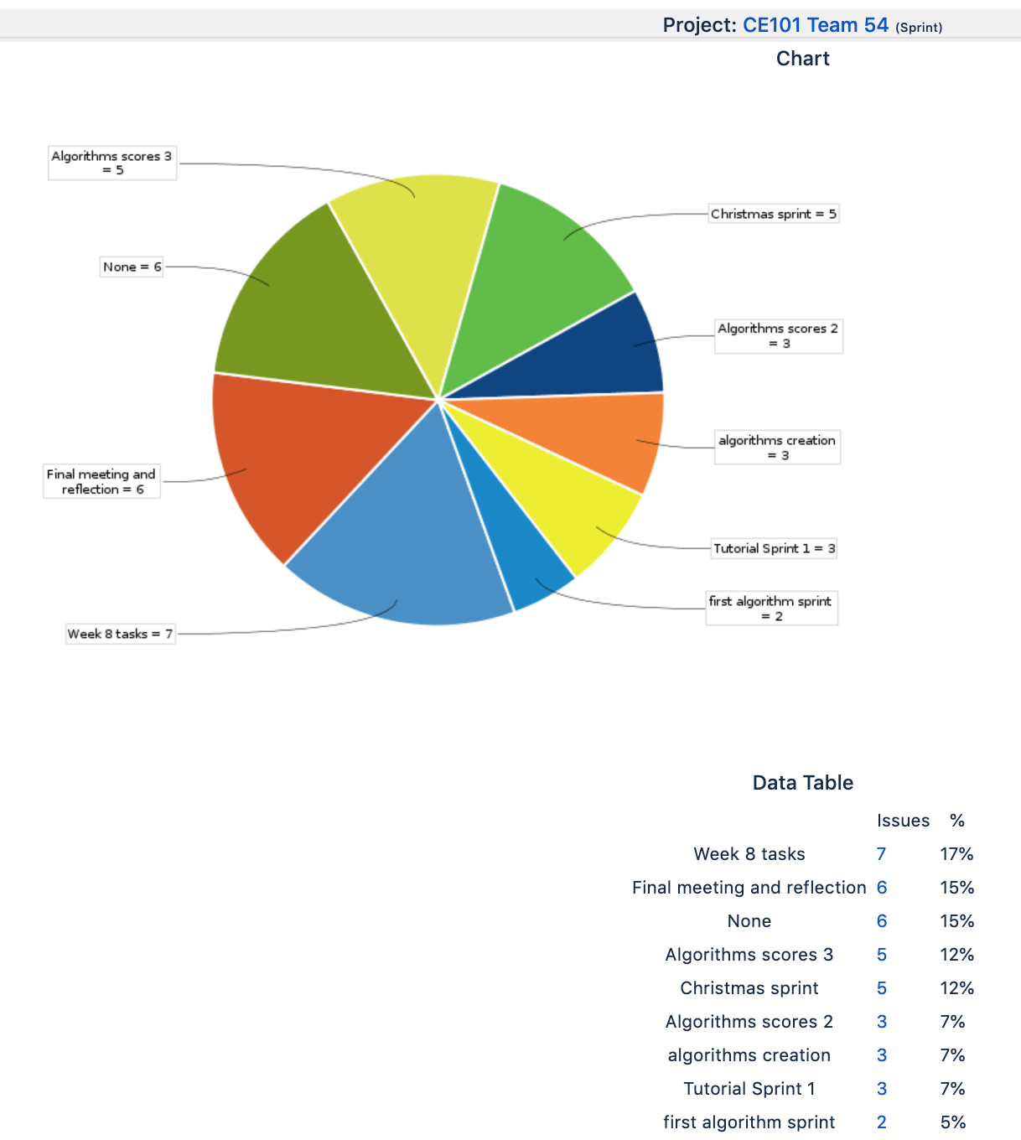



In November, our group was informed of the topic – *Machine-learning algorithm* to estimate house prices. The group consisted of 6 individuals: [names removed]. Our goal was to create an algorithm that took in a set of variables and taught itself to estimate the sale price of other houses. As a group, we wanted to address key points while relating them to the relevant data from the *train file*. Our first step in the process was combing through the *train data* and selecting the variables that correlate the most with the sale price. We collectively came to the conclusion that, for the algorithm to be “*machine-learning*”, it must be able to select the variables it deems most relevant. During a scrum meeting, we decided to test a *correlation matrix* via a *heatmap*. Prior to this, we were utilizing all the variables to train the algorithm and the results were below par. Now, using a *correlation matrix*, the algorithm took only the variables with a correlation value higher than a specified value. This boosted our score up 317 rankings. Upon this minor success, we starting functioning more as a team; slowly but surely we were progressing and our rank was increasing. We held a meeting every week to assess the progress of each member; if a member was stuck or in need of assistance, he could request our help as a group and we would come together and brainstorm. At the end of each meeting we updated the issues and completed sprints, set the tasks, and issues for the next week. Each week, another member would get the experience of being the *scrum master* and decide the direction in which the project would progress and manage each member.

The experience was enriching and as we neared the end of this project, we came to realize, after some **reflection**, that there were tasks we could have done differently, or the events we could have handled efficiently. Initially, our group had only 3 functioning members. This impacted our workflow and we progressed slowing during the first semester. Moreover, our January exams further pushed back our project work. It was only a month prior to the deadline when our team had three new members join us. By this time, our algorithm was built upon too many blocks of code, that new programmers would have a great difficulty understanding it. After the second meeting with the new members, we decided the benefit of their possible contribution was not high enough to abate the cost and we assigned them the presentation as their primary contribution to the project. Although, they were also trying to contribute to the algorithm. In meetings, they gave us ideas to try, for example: *gradient boosting* was proposed which raised our ranking by 143 places. Additionally, creation of the code began later than anticipated. This prevented us from trying other ideas towards the end of the term due to deadlines and tests. The most significant learning outcome was not all members will contribute equally. This is also reflected in real-life, many times, you will find that the workload is not split equitably. There are times where a group will have to cover for a slacker in order to cover the scope or produce a product by the deadline. Overall, we believe that this module has been a learning and valuable experience.

### 2.II.b Detailed report of each team members contribution to the project

Lewis initialized the process of algorithm creation. After undertaking some in-depth research over the Christmas break, he decided basing our algorithm of the random forest algorithm.

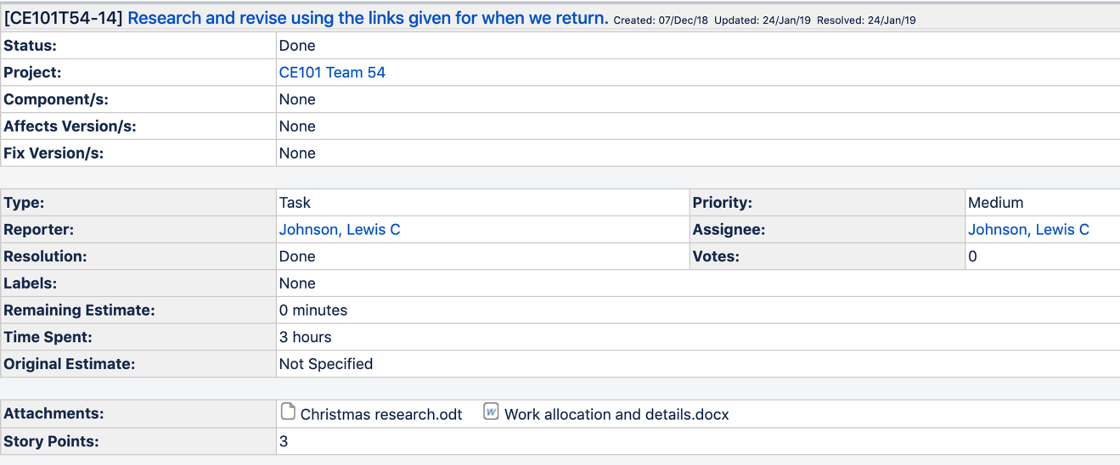

Lewis put together the initial algorithm almost single headedly.

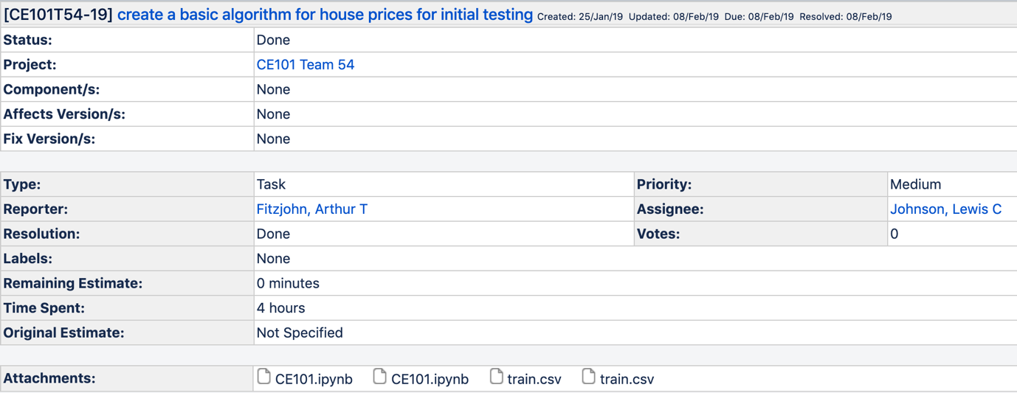

Additionally, he continued contributing toward the algorithm after Arnav had increased the ranking of the algorithm. Lewis further developed it by including gradient boosting with help from Patrikas. This boosted our ranking by 143 places. Moreover, Lewis continued to work alongside Arthur with refinement of the code. Lewis has been the level-headed, rational voice of the team, sternly reminding us of deadlines and feasibility of ideas that we could implement. He has kept us on the path towards creating the best algorithm possible with the resources we had access to, including time and manpower. Lewis took up the position of team leader during the initial stage of the project when it was only Arthur, Arnav and himself. This was a primary reason we were able to produce a product in time for the demonstration as well as develop a habit to have a weekly scrum meeting.

Arnav built upon the algorithm created by Lewis and solved the issue of no output file. At first, he got the algorithm to produce feasible output and submitted it to Kaggle. This was when we received our first ranking.

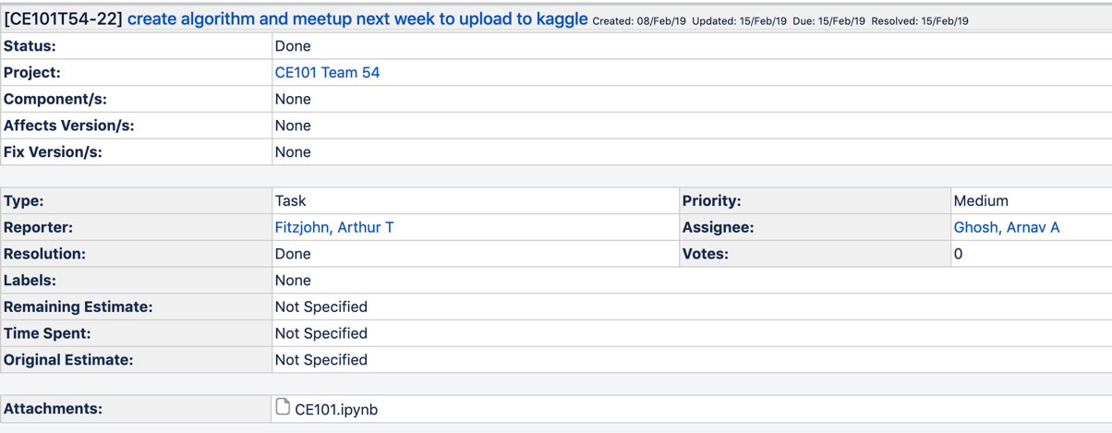

After this, he found that there were some columns that contained large number of null values and safely dropped them. Thirdly, he introduced the correlation matrix into the algorithm for better variable selection. Up to this point, the variables used to train the algorithm were hardcoded. This made the algorithm more flexible and autonomous. It involved creating a heatmap of all the variables in the train data and graphing them against themselves. Now, using the salesprice column, the algorithm would select the variables with a correlation value higher than 0.6. Within this, he found that two of the variables were correlated with each other and hence would double their significance (GarageArea and GarageCars). To mitigate this he removed the GarageArea due to it having a lower correlation value with the sale price. The resulting output raised our ranking by 317 places on the leader board.

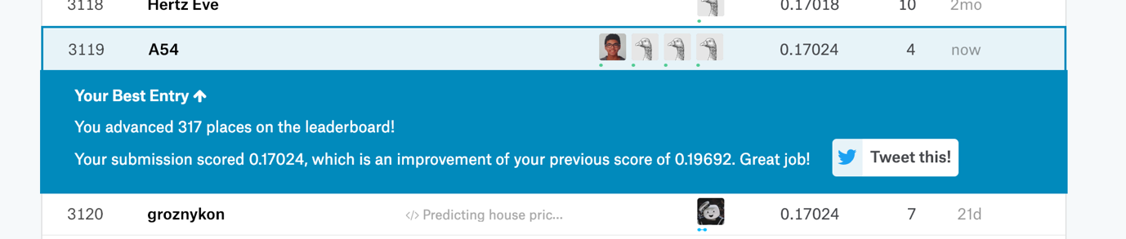

Arthur is the most familiar, of our team, with algorithm. His initial contributions were not significant, however, in the latter stages he has been our primary programmer. He has tried various different ideas proposed in our scrum meetings; the most significant success was when he discovered that hardcoding different combinations of variables to train our algorithm raised our ranking. 

Arthur’s various minute contributions throughout the process of refining our algorithm, from the day we first generated an output and achieved a rank, have slowly but surely raised our ranking. It has been through his debugging and testing that we integrated different functions into the algorithm and have successfully generated output. Arthur also gave the new members a walkthrough of the algorithm and gave them an understanding of what we had achieved. It was after this that Patrikas had the confidence to suggest improvements and ideas in the team meetings and as a result implement gradient boosting with Lewis.

Patrikas, one of the new members, managed to help improve our ranking despite the great difficulty in understanding our already complex algorithm. Working together with Lewis, he researched higher ranked algorithms on Kaggle and collectively, they implemented gradient boosting. This boosted our algorithm by 143 places. Patrikas also contributed ideas during our scrum meetings and took measures to show us evidence and links to such ideas. He worked with Arthur to improve the algorithm as they tried to adapt the ideas Patrikas had shared. However, not all of it was at a level they could achieve. The top-end ideas were created by computer scientists already prominent in the industry and hence, it was difficult to adapt code that we could not comprehend. Additionally, Patrikas held the position of scrum master and conducted one of our scrum meetings. He decided the direction in which we would proceed: Arthur, Bahir, Yuhang and himself would focus on further improving our algorithm while Lewis and I would begin writing the team report. This would allow us to both raise our ranking, give the new members a chance to get some familiarity with the project without falling behind schedule and producing a detailed report.

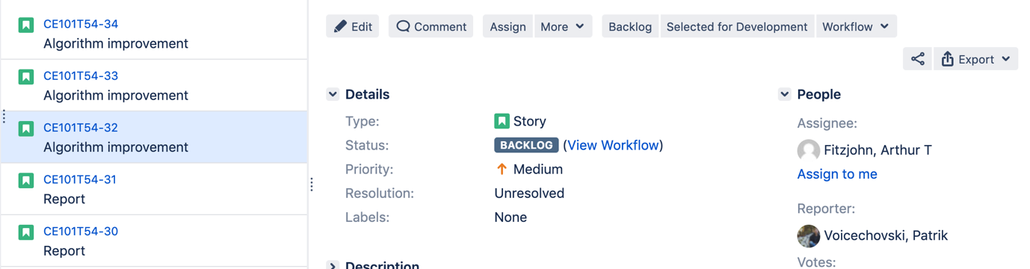

Bahir and Yuhang were also new members. They joined with Patrikas in the later stages of the project. However, they were unable to contribute to the algorithm. Instead, they worked on a script for the demonstration and created the presentation. They were present during our scrum meetings and attempted to contribute ideas. It was evident that they were trying to be involved. Although, none of the new members missed a scrum meeting since they joined. The time by which our had merged was far too late in the project-making process.

# Chapter 3 Product Development

## 3.I An introduction to Product Development

#### Product Development

“Product development” refers to the method you use when developing or modifying a product. Many different methodologies have been developed to aid companies when deciding how best to break down and organise the development of their product. Developing a product without first planning how will usually result in very inefficient use of time and resources as well as unhappy customers as the final product may not be exactly what they wanted.  
Methodologies break the problem down into smaller issues, allowing them to be resolved by individual teams.

#### Waterfall Methodology

The tasks within the methodology are typically only moved through one way, sequentially. The tasks are usually ordered similar to: “Requirements – Design – Implementation – Verification – Maintenance”. This sequential design usually makes things costly if a mistake was made at any stage. For example, if improper analysis was done in the requirements stage, the whole project may have to be scrapped and started anew because the product is not even attempting to do what the customer wants. Similarly, if the customer's needs change midway through the project, there is nothing in the waterfall methodology to facilitate this change and it may result in a complete restart. Therefore, this methodology should only be used when the development team is incredibly clear on what is required by the customer (usually if the developers are creating something for themselves) and if the sudden need for change is extremely unlikely (usually if the expected development time is very short).

#### Agile Methodology

Agile methodologies work more iteratively than the waterfall model. The problem is usually separated into the same tasks, but at least some of the tasks form a loop as the customer is shown prototypes of each aspect of the product at the end of each loop. If the customer is unhappy with the product, then another analysis will be made of the customer's exact requirements and the loop will begin again. This will be repeated until the customer is happy with the product.  
The tasks in agile methodologies are usually ordered similar to: “Requirements – Design – Implementation – Verification”, which will loop, with maintenance being a continual process after the customer has bought the product.

#### Scrum

“Scrum” is a framework that is commonly used with agile methodologies as it facilitates short bursts of production that are periodically monitored and can therefore be adjusted to facilitate the needs of the customer / the ideas of the product owner. For our project we have received information on which features are required from Kaggle, though we have our own supervisors and Vishuu for queries regarding the project.

The “product owner” is the person who knows how the final product should be and is therefore to be questioned about specific design choices, but does not usually have any direct interaction with product development (like programming or construction of physical components).

The “scrum master” is in charge of setting the workload for individual developers and scheduling meetups as well as making sure that everyone has a clear idea of what they have been instructed to do. The scrum master is often also a part of the scrum team. For our project the scrum master has been elected on a bi-weekly basis as instructed.

The scrum team is a small group of people who work together to complete their tasks within the time limit set by their scrum master. This is called a sprint. For our project all members of our group were set tasks during each scrum and worked together to complete them. We used JIRA for simple queries but the messenger app proved more useful for open discussions regarding work and meetups.

Our sprints will usually be two weeks long with a group session lasting 2 hours at the end of each sprint. During this time we will decide our scrum master and decide the workload for each member after reviewing the work completed during the last sprint.

## 3.II The Context

### 3.II.a The Customer/ End User

#### Supervisors

We need to make a product that the supervisors approve of and we are showing the work that we are doing by using Jira, Github and Kaggle.

#### Team members

We need to make a product that helps us learn how to use object oriented programming in data science. This will help us in our future study/ careers to analyse datasets and write reports about them.

#### Estate agent professionals

Estate agents can use the algorithms from this project to predict future house prices in individual areas whilst also showing which features are most likely to influence house price negotiations. This allows them to make the best decisions on which houses to buy and sell as well as which features to showcase when marketing their buildings.

As the training data used for the project is from Iowa only, the outputs of the algorithm submitted for the assignment may not be hugely applicable anywhere else as the general opinions of the public when it comes to housing may vary greatly from area to area or country to country. However, the algorithms to create these predictions should be usable in any area as long as a large enough quantity of accurate data has been entered.

### 3.II.b Legal and Ethical Matters

The technologies that we are using in this project are the programming language Python 3.7 and Jupyter Notebook.

#### Python

Python is an open source technology which means that we are able to use it for educational purposes without needing to pay for it.[5] It is a programming language and we use its syntax to control the flow of operations of our program.

#### Jupyter Notebook

Jupyter notebook is programming software which allows us to write markup between blocks of code that can be run individually. It is an open source project .[6]

#### Ethical issues

We do not believe that our project poses any risk to privacy or other sensitive information as data used in our algorithms has no need of any details connecting the houses to individual people so they should not be collected and will not be used to create the ouput. We also do not think that our project could affect society (presently or in the future) in a negative way as it only empowers estate agents which has potential to improve the economy.

### 3.II.c Sustainability

Having read through the principles of DEFRA, we would like to declare that this project does not have significant effect on the environment, justice, health, science or governance. We do, however, predict this project to have a positive effect on the economy because more informed trade will be occurring in the housing market.  
Our product should not consume a significant amount of energy unless a substantial amount of data is entered as it should only be run once for each set of data and has only taken a matter of seconds to complete its predictions in previous tests.

### 3.II.d Health and Safety Matters

As the project is purely software and has no physical components, there should not be any physical health and safety concerns for the user other than those to be expected from using a computer. We also do not believe that the gathering and use of housing data to predict prices poses any significant risk to mental health.

## 3.III The Team Product

### 3.III.a Product Description

We have created an algorithm that estimates the price of housing when given a large quantity of accurate data.

This will take appropriate data in the form of a CSV file and will output the estimate for the house prices along with their relevant Ids in another CSV file.

We used the “Random Forests” model amongst other things to transform the given data into an accurate estimate.

The product is limited in that it needs a large amount of accurate input data in order to output an accurate result. The algorithm could make better estimates for missing data in each column to deal with this issue.

test.csv

train.csv

Python application running on Jupyter.

OutputCSV.csv

### 3.III.b Product Demonstration

The algorithm was tested using data from Iowa and the output was submitted to Kaggle to receive a rank. Many columns with different kinds of data were also used, meaning that our product should deal with any type of data given.

**Here are some of our Code Blocks:**

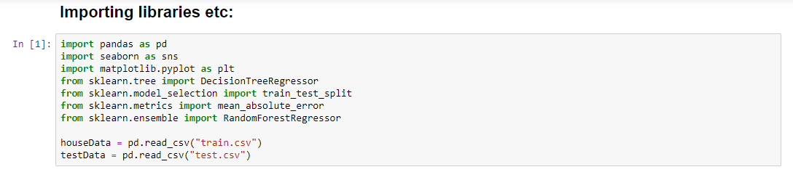

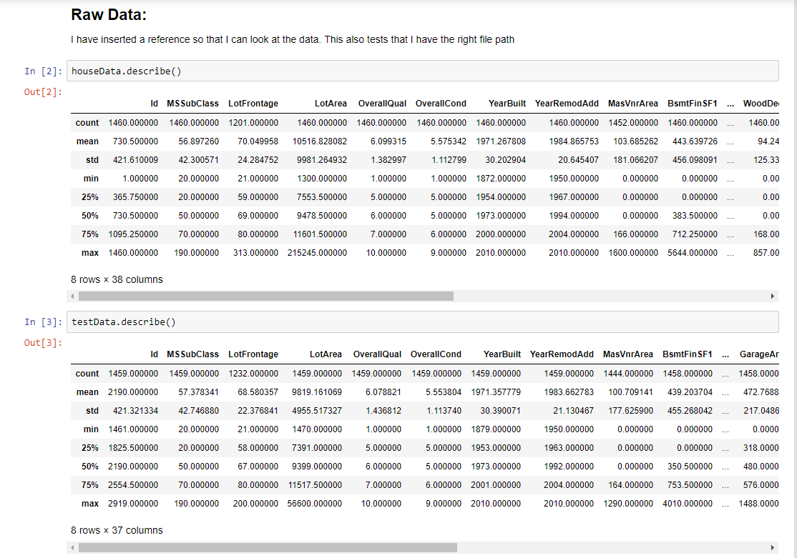

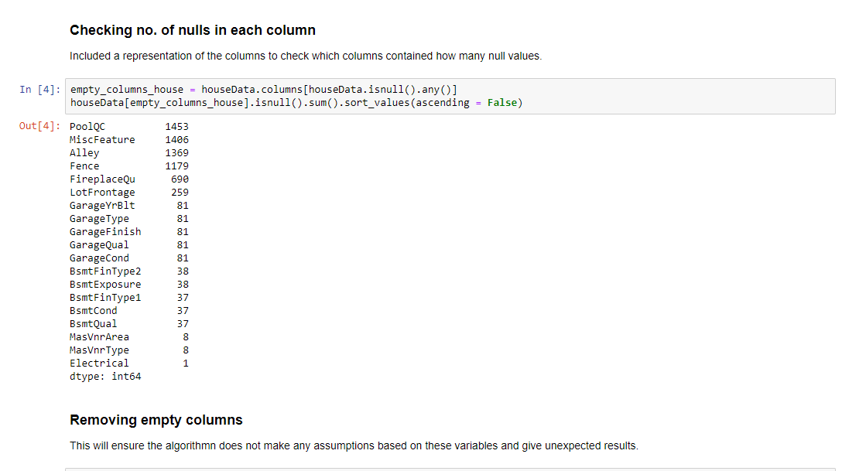

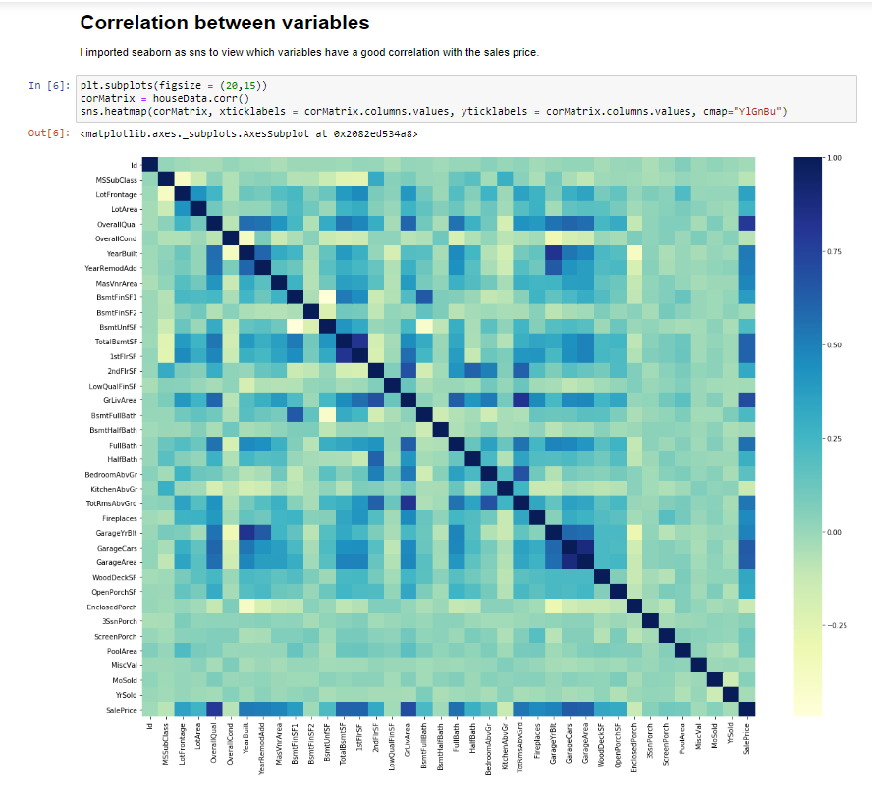

**Outputting Data to a CSV:**



# Chapter 4: Project Management

## 4.I An introduction to Project Management

A **project** is an array of linked operations that has defined a beginning and end term, and hence a pre-determined scope and resources. These operations will lead to the accomplishment of a singular, overall goal. **Project management**, is then, deciding upon operations and time required to complete them, taking into account the scope and quality. Moreover, this should take into consideration “pitfalls such as delays, cost overruns, lack of resources, the customer wanting more for less.”[7] Furthermore, a **project manager**, to observe, manage and report on each members progress, should be appointed. A project can be determined using a variety of variables:

* Size/cost: investment of money, people and time.
* Importance: mission critical
* Duration: critical time window
* Complexity: across Departments, organizations, countries
* Technology: is it off the shelf or breaking new ground?
* Risk: what if?

A **risk** is a possible outcome that may arise and as a result affect the creation process. **Risk management**, is then, identifying, planning for and assigning responsibility for each risk to a suitable member. Moreover, this member is required to provide resolution for the risk and keep the project manager up-to-date on it.[8] There are clearly established roles in the risk management process; the risk originator, the project manager, the risk owner, and the response owner. The *risk originator*identifies the risk, the *project manager* monitors the activities to control it, the *risk owner* is the person designated to manage the risk, and the *response owner* is responsible for the backup plan respectively. The most common types of risks are:

* **Schedule risk**, the risk that activities will take longer than expected. Slippages in schedule typically increase costs and, also, delay the receipt of project benefits, with a possible loss of competitive advantage.
* **Performance risk**, the risk that the project will fail to produce results consistent with project specifications.

A project can be partitioned into five distinct operations. Scoping, planning, executing, monitoring and concluding. **Scoping** identifies clients, establishes concrete goals and specifications. **Planning** involves setting tasks and their respective deadlines and cost; it must consider an assessment of risks involved. **Execution** requires a project manager to assign roles and responsibilities to group members, and in addition, to monitor members throughout the entire process and provide a system for communication. **Monitoring** the overall project is overseen by the project manager; addressing issues, deciding on modifications suggested/required and keeping other members updated on the progression of the project. **Concluding** is the final check of the project against pre-determined goals and task set within the duration of the project and delivering it to the client.

**Project planning** is beneficial to most operations. It provides an efficient, strategic formula toward success. It enables project members to deliver on time, deliver desired quality, and with the set resources. A proper plan gives members a clear focus and objective to achieve. Additionally, a realistic plan will have countermeasures for possible risks in place or, if necessary, contingencies for larger issues.

Project management methodologies, briefly, are collections of guiding principles and operations. They define the work ethic and mode of communication one employs during the process. Four main types include: Traditional (Waterfall), Extreme, Agile, and Emertxe.[9] We will focus on the *Agile* method: It emphasizes adaptability and improvisation. Unlike the tradition way, which implements a more linear approach to a solution using pre-established guidelines and technology. Agile focuses on an explorative approach to create modern solutions.

**JIRA** is project management system built to suit the agile methodology. All projects are entered into the main database and each one progresses through various workflows; These control the status of the project including rules by which it transitions over to other statuses.[10] “A **Gantt chart** displays the planned activities against time. Each activity is represented by a bar; the position and length of the bar reflects the start date, duration and end date of the activity.”[11] Milestone charts enable the team to view their progress and upcoming deadlines.

Common reasons for **project** **failure** are: either too complex or inadequate requirements, indecisive management, inaccurate estimates and planning, inadequate staff resources, and the size of the project’s scope. The countermeasures to mitigate failure are **prevention** and **intervention**. Prevention involves proper planning, monitoring, risk management, and reviewing the effectiveness of the current plan. Intervention involves actions taken by the client as well as root cause analysis. **Project revision** is necessary in-case of imminent failure; the involvement of the client is necessary as it relates to the scope of the project and its product.

## 4.II Project Management Report

### 4.II.a Summary of Teams Project management in Jira

The platform enabled us apply the Agile methodology to its fullest extent. We set an overall timeline and initialised new sprints each week. This project was an explorative task; most of us had minimal knowledge on how we would go about creating the product. Therefore, it was more efficient to utilise a management tool that supported changing requirements throughout the process by measuring and evaluating the status of a project. This supported implementation of new ideas that we determined as we learnt out more about the task. Moreover, it provided better insight into the progress of our project and minimized the risks related to development. JIRA enabled a re-evaluation of the project each week and thus, could be evidenced by the scrum master to decide the direction of workflow. Additionally, JIRA promotes flexibility in cases where events occur that were not included during the scrum meetings. E.g. Arthur’s medical appointments or Arnav’s fever. JIRA can also be used to estimate whether the project will meet the deadline. Each member can assign a story point for their task and a burndown chart can be generated to display the results.



Velocity charts were also helpful to gauge the performance of the team over time. It enabled us to verify our estimated workflow against our resultant contributions.

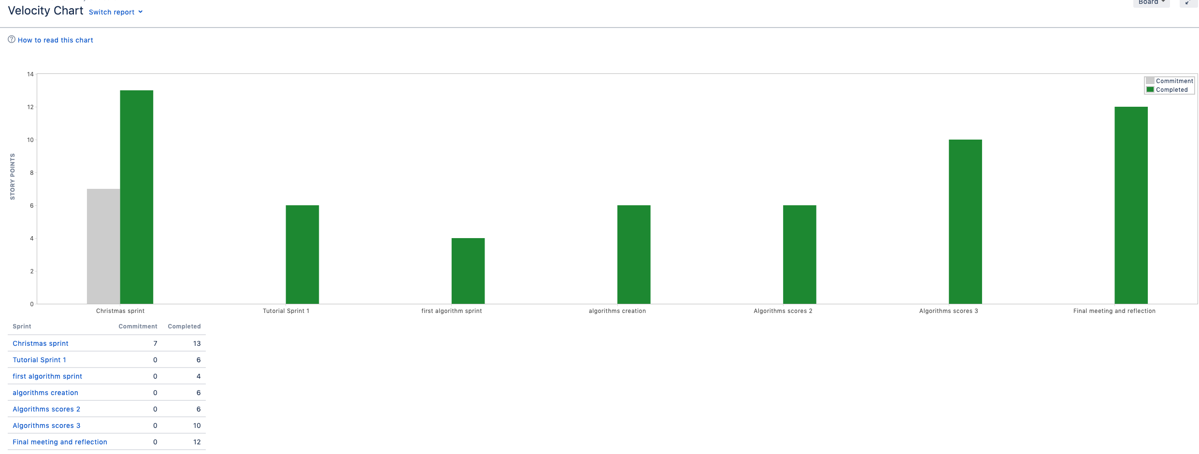

The cumulative flow diagram helped understand the efficacy of our team: the number of issues we created, completed and had carried over or remained. It was an effective tool to motivate as well as remind us of the workload we needed to cover by each scrum meeting. 

### 4.II.b An evaluation of the Project management

Overall, the project was a moderate success. We did not achieve our initial goal of having a ranking under 1000 on Kaggle. We were overly optimistic and failed to plan efficiently. In the second term, we started planning more rationally, keeping a timeline in mind and clear objectives in place. We created new sprints each week and set tasks for each of us within them. Our meetings were relatively successful and productive. We compartmentalised the project and worked parallel to one another, and in the event of an issue, we came together during scrum meetings and collaborated to mitigate the issue. It required time to eventually achieve common ground and start working collectively toward the goal. We delayed the initialisation of our algorithm and this impacted the variety of functions we could implement and test. Moreover, we could have been more efficient with our time management. Sometimes, issues set were vague and this reduced the work put towards achieving it. Not all members of the team were present for some meetings with our supervisor. Furthermore, three of the six initial members of our group were absent throughout the process. It was already too late when we received new members, however, now that we had already been through the process of integrating into a newly formed team, we found including these new members occurred swiftly. We assigned them tasks and began collaborating within a week of our initial meeting. As a result, we believe this module has been an enriching, new experience that has taught us an important skill regardless of our overall score on the product.

# Chapter 5: Conclusions

1. Lewis-McClear, Kyle and Taylor, M.S. (1998) "Psychological contract breach and the employment exchange: perceptions from employees and employers" Paper Presented to the Academy of Management, San Diego, August 1998.
2. Marques, M. and Ochoa, S.F., 2014, April. Improving teamwork in students software projects. In 2014 IEEE 27th Conference on Software Engineering Education and Training (CSEE&T) (pp. 99-108). IEEE.
3. Lingard, R.W., 2010. Teaching and assessing teamwork skills in engineering and computer science. Journal of Systemics, Cybernetics and Informatics, 18(1), pp.34-37.
4. Cobb, A.T., 2011. Leading project teams: The basics of project management and team leadership. Sage.
5. Jupyter.org. (2019). Project Jupyter. [online] Available at: https://jupyter.org/about [Accessed 25 Mar. 2019].
6. Python Software Foundation. (2019). History and License. Retrieved February 22, 2019, from https://docs.python.org/3/license.html
7. Wysocki, R.K., 2011. Executive's guide to project management: organizational processes and practices for supporting complex projects. John Wiley & Sons.
8. Kerzner, H. and Kerzner, H.R., 2017. Project management: a systems approach to planning, scheduling, and controlling. John Wiley & Sons.
9. Nerur, Sridhar, RadhaKanta Mahapatra, and George Mangalaraj. "Challenges of migrating to agile methodologies." Communications of the ACM 48.5 (2005): 72-78.
10. Ortu, M., Destefanis, G., Kassab, M. and Marchesi, M., 2015, May. Measuring and understanding the effectiveness of jira developers communities. In Proceedings of the Sixth International Workshop on Emerging Trends in Software Metrics (pp. 3-10). IEEE Press.
11. Wilson, J.M., 2003. Gantt charts: A centenary appreciation. European Journal of Operational Research, 149(2), pp.430-437.